Name: Fatima Ibrahim Mohamad AL-Thary

Group:5 – Dep:CS – subject: CS – Assignment "1"

Section 1: Linux Basics

1. What is Linux, and how does it differ from other operating systems like Windows and macOS?

Linux is an open-source operating system based on the Linux kernel. It differs from Windows and macOS by being free, flexible, and open-source, allowing users to modify the system to suit their needs.

2. Name three popular Linux distributions and briefly describe one of them.

Popular distributions: Ubuntu, Fedora, Debian.  
Ubuntu: A popular Linux distribution designed to be user-friendly for beginners, with a graphical user interface.

3. What is the root directory in Linux, and why is it important?

The root directory / is the top level in the Linux file system. All files and directories stem from it.

1. Explain the difference between an absolute path and a relative path in Linux.

An absolute path is the full path to a file or folder starting from the root directory, such as /home/user/file.txt.  
A relative path starts from the current directory, such as ./file.txt if you're already in the folder containing the file.

4. What command would you use to update the package list on a Debian-based system?

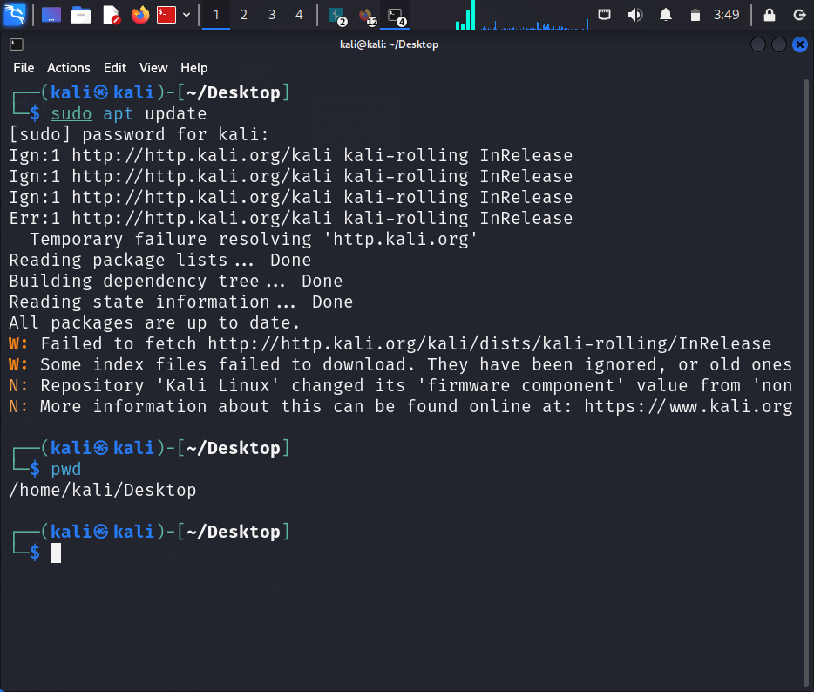

Section 2: Basic Commands and Navigation

1. Write the command to display the current working directory.



1. How do you change to the /etc directory from your current location?

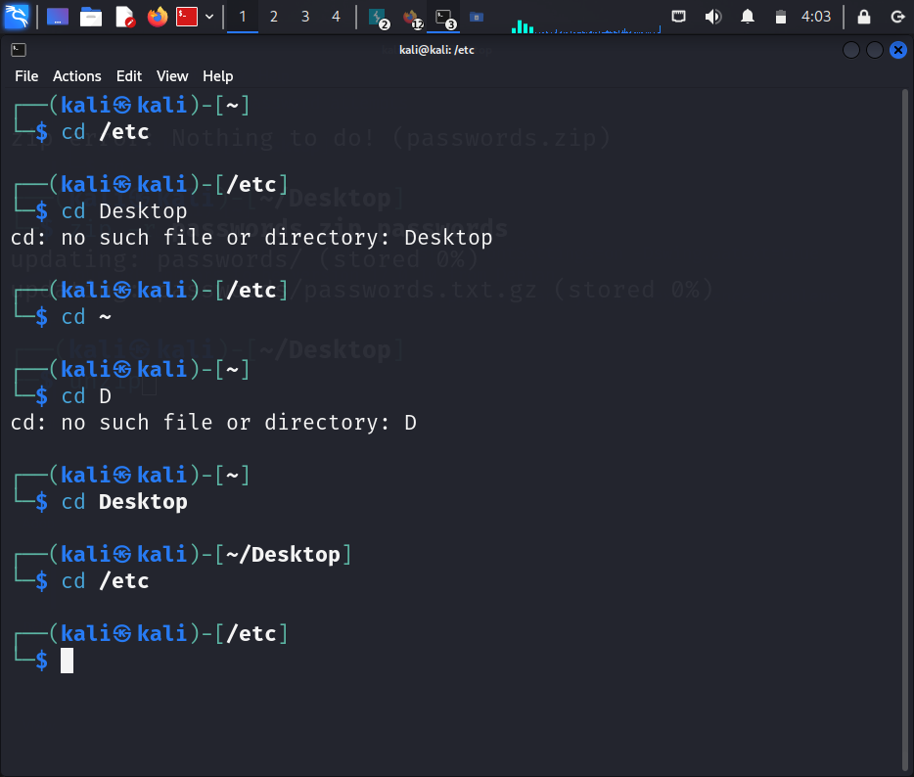

1. List the contents of the /home directory, including hidden files, in a detailed format.

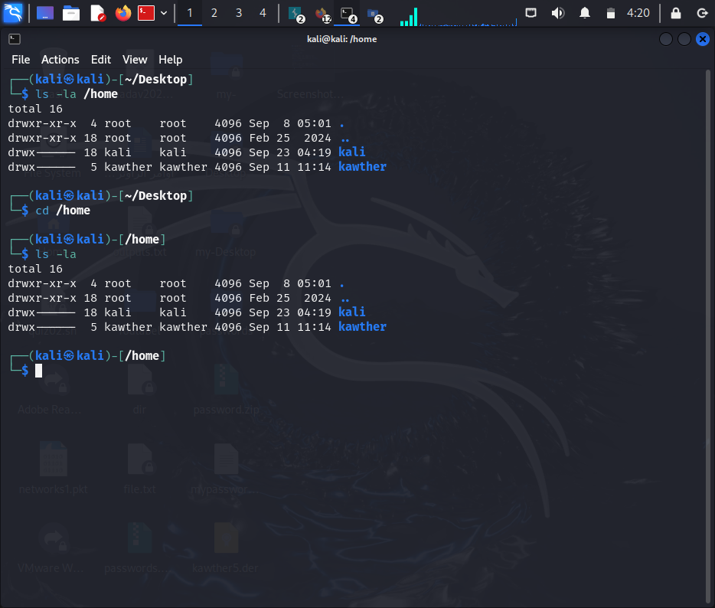

1. Explain the purpose of the ls -l command and the information it provides.

The ls -l command displays a detailed list of directory contents. It provides information on permissions, number of links, owner, group, size, modification date, and file name.

1. What command can be used to return to the home directory from anywhere in the file system?

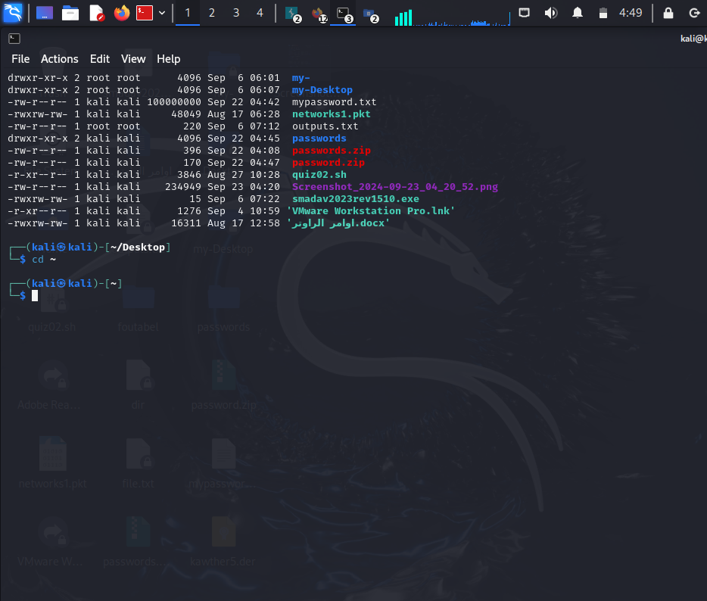

Section 3: File Management

1. Write the command to create an empty file named testfile.txt.

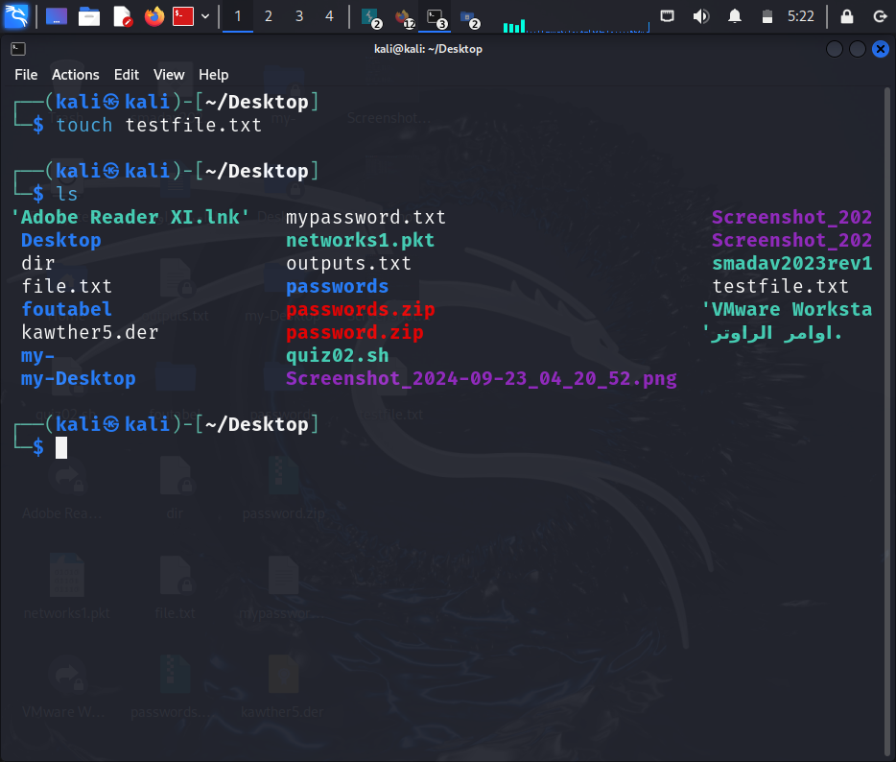

1. How do you create a directory named testdir?

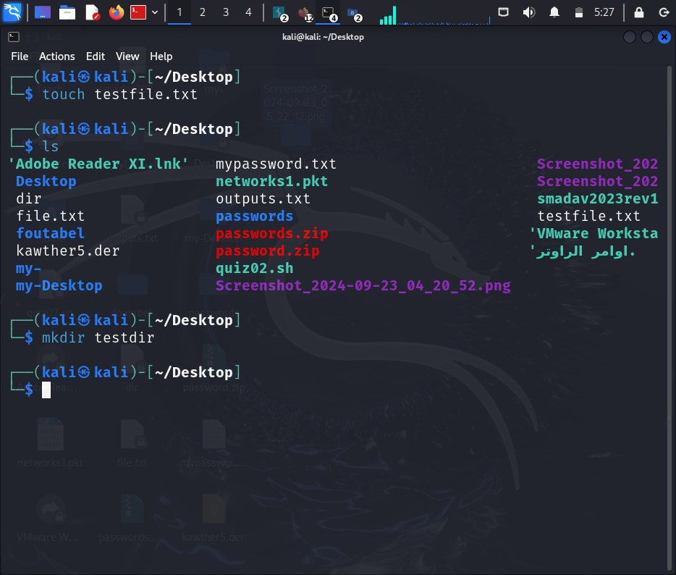

1. Write the command to copy testfile.txt to backup_testfile.txt

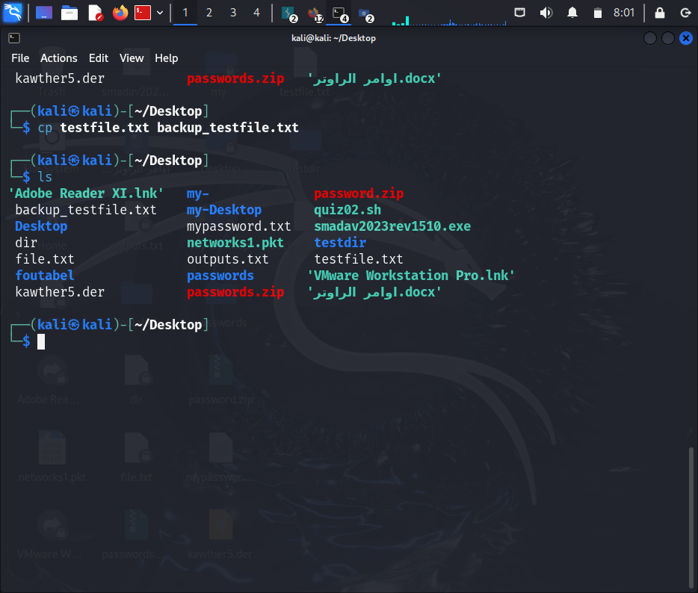

1. What command would you use to move (rename) testfile.txt to newfile.txt?

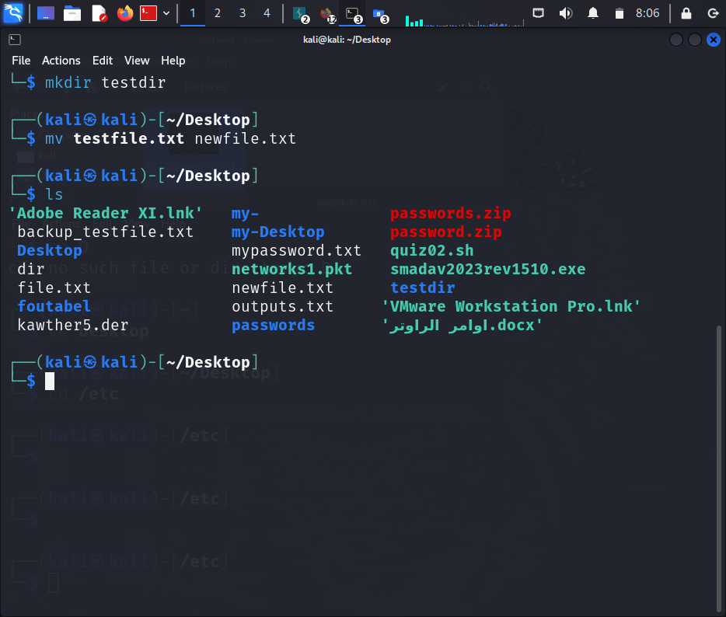

1. Write the command to delete the directory testdir and its contents.

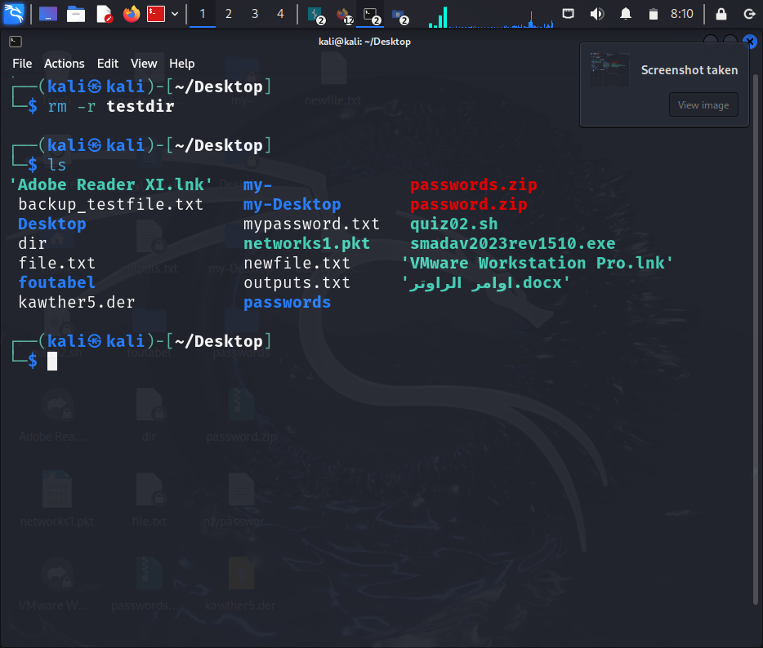

Section 4: User and Group Management

1. How can you display all the users in the system?

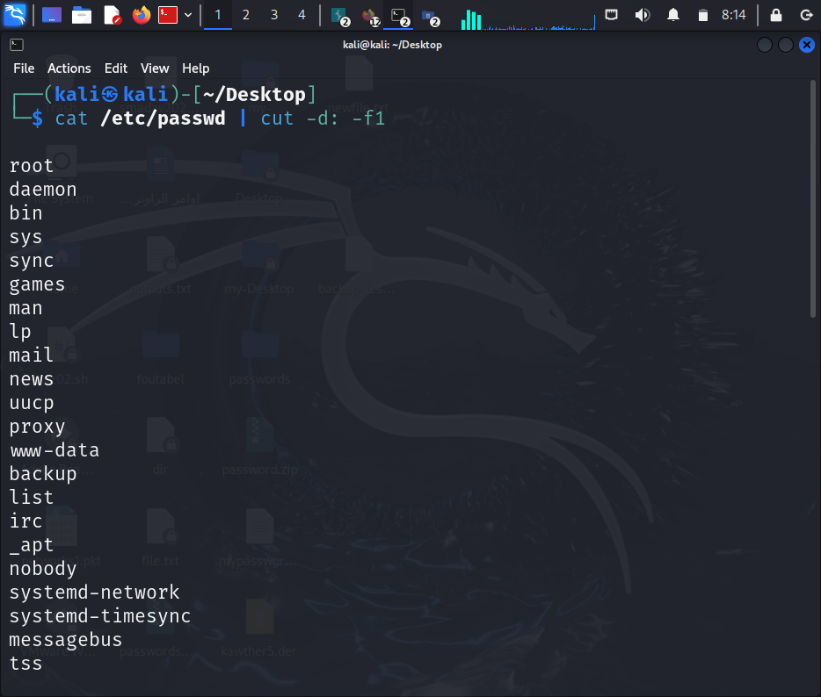

1. Write the command to create a new user named newuser.

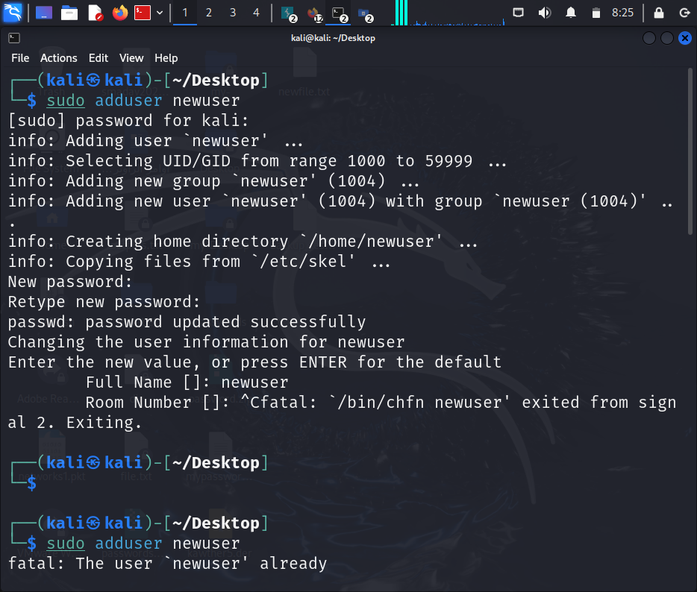

1. How do you create a new group named newgroup?

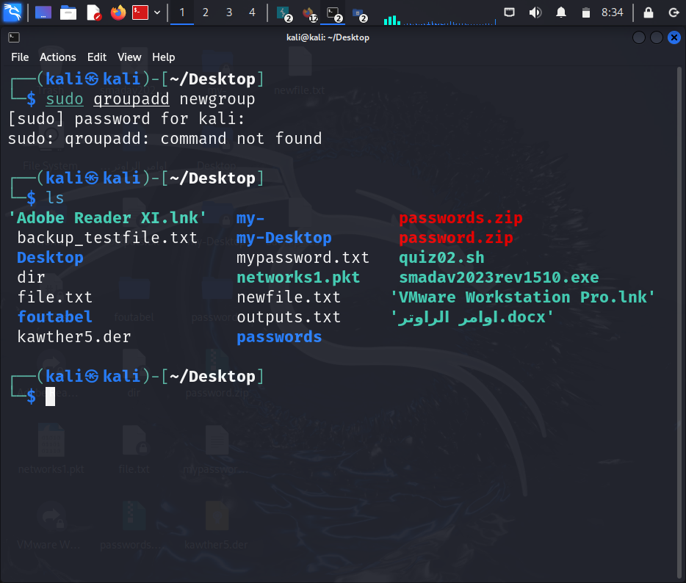

1. Write the command to add the user newuser to the group newgroup.

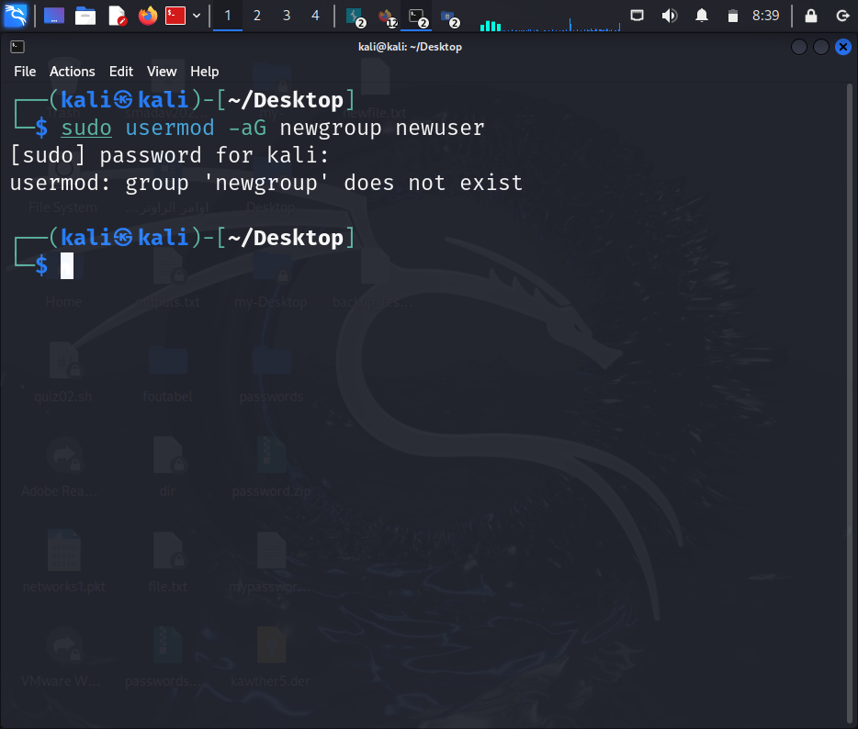

1. What command would you use to change the password for the user newuser?

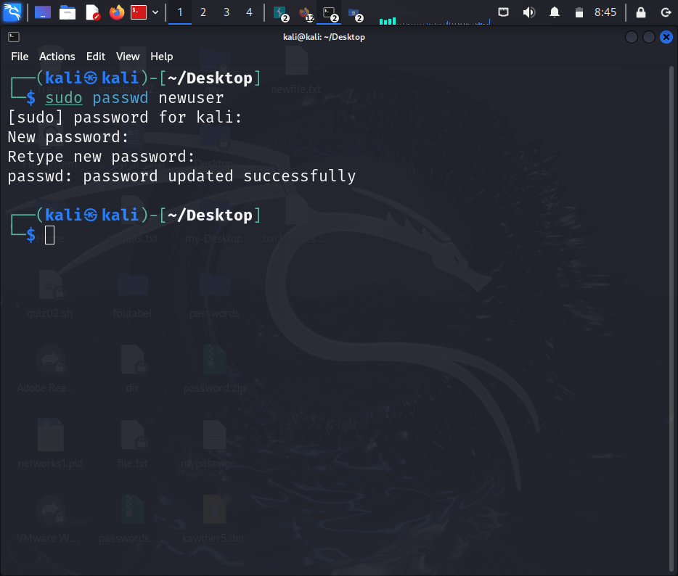

Section 5: Practical Application

1. Describe the steps you would take to install a Linux distribution on a virtual

machine.

1. Download the ISO image for the desired Linux distribution.  
2. Open a virtual machine program like VirtualBox or VMware.  
3. Create a new virtual machine and select Linux as the operating system.  
4. Allocate memory and disk space.  
5. Select the ISO file to start the installation.  
6. Follow the on-screen instructions to complete the installation.

1. If you are in the directory /home/user, what command would you use to navigate to /var/log?

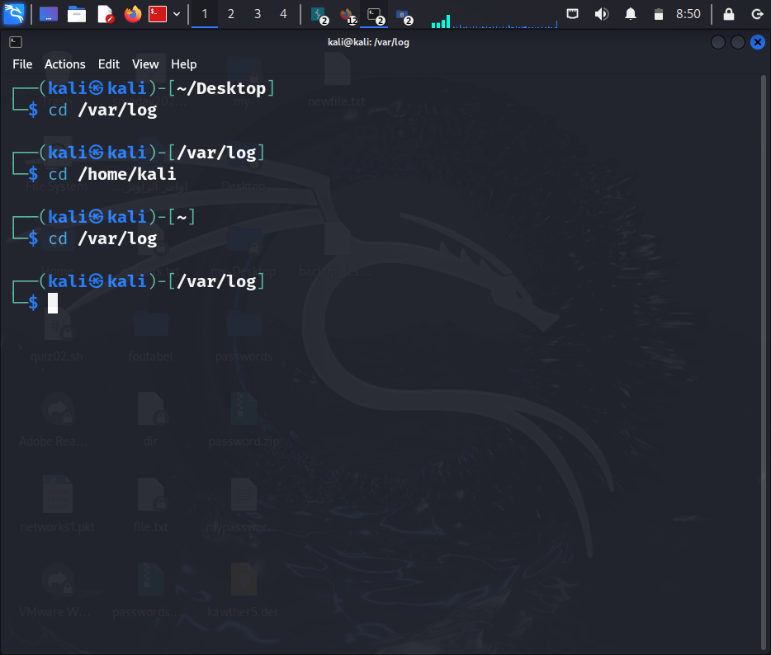

1. How do you display the contents of the current directory in a human-readable format?

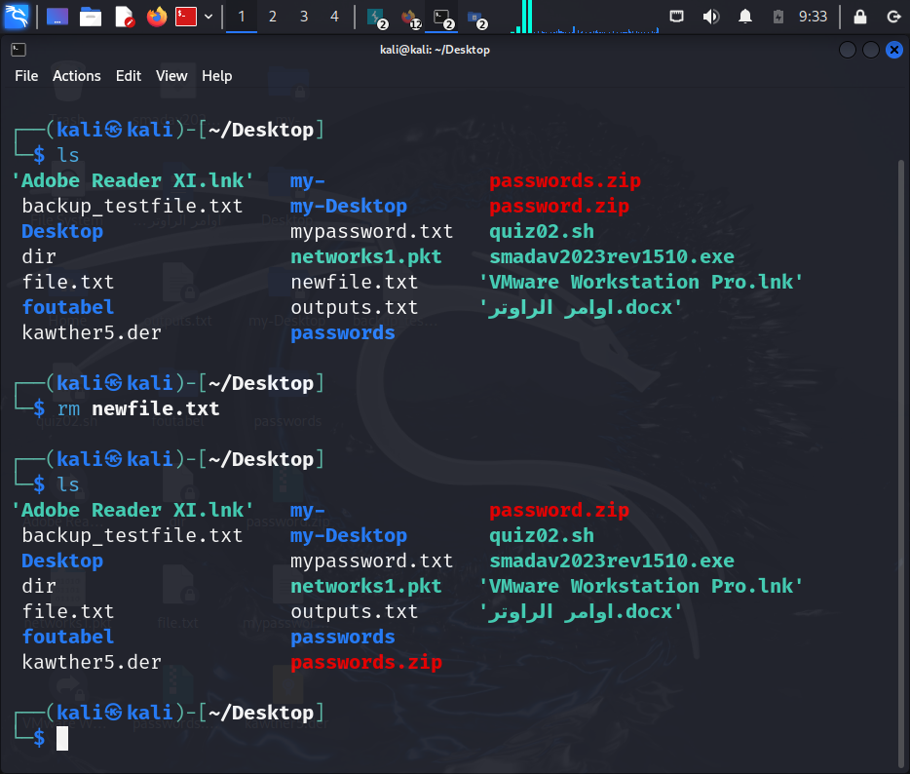

. Explain what the following command does: cp -r /home/user/docs /home/user/docs_backup.

It recursively copies the contents of the docs directory (including all files and subdirectories) to the docs_backup directory.

1. What is the difference between the `rm` and `rm -r` commands?

**`rm`**: This command is used to delete individual files. It cannot remove directories by itself unless additional options are specified.

**`rm -r` (recursive)**: This command deletes directories and their contents recursively. It is used to remove directories along with all their subdirectories and files.

In short, `rm` is for individual files, while `rm -r` is for directories and their contents.

22. Explain the significance of the `/etc` directory in Linux.

The `/etc` directory in Linux is a critical part of the system that stores system-wide configuration files and settings.

GoOd Luck ☺